St. Leander Church
Santinig Choir

Christmas Eve Family Mass


December 24
5:00PM

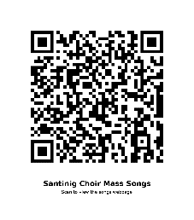 | If found, please return to  St. Leander Parish Office  474 W. Estudillo Ave.  San Leandro, CA 94577  (510) 895-5631

Prelude/ Caroling | Ellen then Choir – CHILD OF THE POOR/WHAT CHILD IS THIS | 318, 320
1 Gathering Song | O COME, ALL YE FAITHFUL  (VERSES 1,4,2) | 308
3 Glory | Glory to God by Daniel Laginya | Handout
4 Responsorial Psalm RA16 | Forever I will sing the goodness of the Lord. | Ps
5 Gospel Acclamation RA17 | Acclamation No. VII | Ps
6 Preparation of Gifts | HARK! THE HERALD ANGELS SING | 305
7-9 Holy to Amen | Heritage Mass | 45, 47,49
10 L/G | Heritage Mass | 50
11 Communion | SILENT NIGHT/NIGHT OF SILENCE | 311
12 Communion 2 | AWAY IN A MANGER | 319
13 Sending Forth | JOY TO THE WORLD | 310

